7. nbm 7-1
7. Product Tracking 7-1
Adding Product Tracking Records 7-1
Quantities Dispensed by Purpose of Use 7-3
Treatment Tracking 7-4
Tracking ART Patients 7-4
Tracking TB Treatments 7-5
Viewing Product Tracking Records 7-5
Method 1 – Finding a facility by code 7-5
Method 2 – Finding a facility by name 7-5
Editing Product Tracking Records 7-6
Validation Checks 7-6
Opening Balance 7-7
Dispense by Purpose of Use 7-7
Closing Balance 7-7
Average Monthly Consumption 7-8
Quantity Required 7-8
Quantity Issued 7-9
Printing the Selected Product Tracking Record 7-9
Exporting Product Tracking Records 7-9

FILE IS C:\WORK\SCMgr\Documents\new manual\SCMgr-sec7.doc

nbm

This is an information page. Do not include it in the finished manual.

Product Tracking
- In the main menu, click the Product Tracking option.

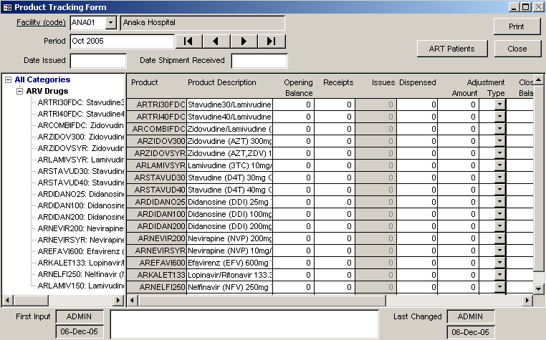
Figure 7-1 – Product Tracking formThe Product Tracking form (Figure 7-1) is displayed.

Adding Product Tracking Records

 | Before you can add product tracking records, you must select the facility that all other facilities ultimately report to. This facility is usually the central storage facility. In some distribution systems it may be a district-level warehouse or an SDP.
- Click on the arrow next to the Facility field, select a facility from the pull-down menu, and click the left mouse button.

- Click the left or right arrow to the right of the Period field and select the reporting period listed on the facility’s submitted report.

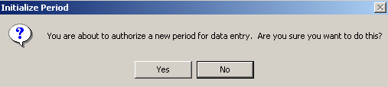
Figure 7-2 – Initialize Reporting Period confirmation messageWhen you select a reporting period for the first time, a confirmation message (Figure 7-2) will be displayed, asking you to authorize the new period for data entry. This message will be displayed only for the first facility for which you are entering data for this period.

- Type the date that the report was received and press <Enter>.

The following three fields apply to a particular health program for which you are collecting data on new, recurring, and pediatric cases.

- Type the number of new cases and press <Enter>.

- Type the number of recurring cases and press <Enter>.

- Type the number of pediatric cases and press <Enter>.

- Type the reported receipts and press <Enter>.

The remaining fields in the Product Tracking form apply to each product listed on the report submitted by the facility.
 | The Product Tracking form does not have a Save button. Data are saved as you move from one field to the next.

- Click a product in the tree menu on the left.

The Opening Balance field for that product will be selected for data entry.

- Type the reported opening balance and press <Enter>.

- Type the reported receipts and press <Enter>.

If the reporting facility is a warehouse only, the Issues column will be enabled and the Dispensed column will be disabled.

If the reporting facility is an SDP, only the Dispensed column will be enabled.

If the facility acts as both a warehouse and an SDP, both columns will be enabled.

- For warehouses, type the reported issues and press <Enter>.

- For SDPs, type the quantities dispensed to users and press <Enter>.

Quantities Dispensed by Purpose of Use
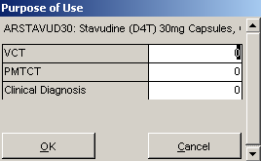
Figure 7-3 – Dispense by Purpose of User formIf you have enabled data collection on purpose of use, the Purpose of Use form (Figure 7-3) will be displayed.

- Type the quantity dispensed for the first purpose of use listed and press <Enter>.

- Repeat step 9 to record quantities dispensed for the other purposes of use listed.

- Click on OK to return to the Product Tracking form.

- Type the reported adjustments (if any) and press <Enter>.

If there are reported adjustments, indicate the adjustment type.

- Click on the arrow to the right of the Adjustment Type pull-down box, select the adjustment type, click the left mouse button, and press <Enter>.

- Type the closing balance and press <Enter>.

If you have enabled data collection on quantities on order, the Quantity on Order field will be enabled.

- Type the quantity on order and press<Enter>.

The AMC, Qty Required and Qty Requested fields apply to facilities that act as SDPs.

- Type the quantity required and press <Enter>.

- Type the quantity requested and press <Enter>.

If you have enabled data collection on service statistics, the New Users and Continuing Users fields will be enabled but the Continuing users field will not be displayed.

- Repeat steps 3-12 to add product tracking records for additional products listed on the report submitted by the facility.

Figure 7-4 – Comments section of Product Tracking formThe Comments section (Figure 7-4) lets you record comments about data submitted on the report. Some comments are automatically added by Supply Chain Manager to note computer-generated adjustments.

- Click the Comment field and type any comments.

- Repeat steps 1-14 to add product tracking records for other facilities or reporting periods.

Treatment Tracking
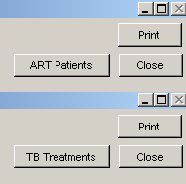
Figure 7-5 – Sample ART Patient and TB Treatment buttonsIf ART or TB has been selected on the System Configuration form during system maintenance (see Section 4 – System Maintenance for more information) the ART Patients or TB Treatment button will be displayed as shown by the sample in Figure 7-5. The button that is displayed depends on which option (ART or TB) was selected. If neither ART nor TB is selected, no button is displayed.

Tracking ART Patients
With the ART Patients button displayed on the Product Tracking form,

- Click on the ART Patients button.

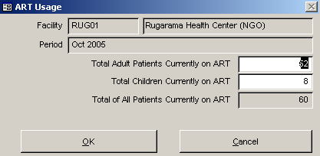
Figure 7-6 – ART Patients formThe ART Patients form is displayed as shown in sample Figure 7-6.

- Click in the Total Adult Patients currently on ART field and type the number of adult patients on ART.

- Click in the Total Children currently on ART field and type the number of children on ART.

- Click in the Total of All Patients currently on ART field and type the total number of patients on ART.
- Click on the Close button to close the ART Patients form and save your entries.

Tracking TB Treatments
With the TB Treatments button displayed on the Product Tracking form,

- Click on the TB Treatments button.
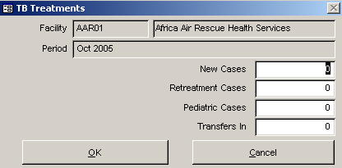
Figure 7-7 – TB Treatments form
The TB Treatments form is displayed (Figure 7-7).

- Click in the New Cases field and type the number of new cases being dealt with.

- Click in the Retreatment Cases field and type the number of retreatment cases being administered.

- Click in the Pediatric Cases field and type the number of Children being treated for TB.

- Click in the Transfers In field and type the number of transfer patients.

- Click on the Close button to close the TB Treatments form and save your entries.

- Click Close when you finish adding product tracking records.

Viewing Product Tracking Records
The Product Tracking form helps you find facilities with associated tracking records by looking up the facility's code or name. By default, facilities are listed by code.

Method 1 – Finding a facility by code
- Click on the arrow next to the Facility (Code) field, select the facility you want from the pull-down menu, and click the left mouse button.

Method 2 – Finding a facility by name
- Click on Facility (Code).

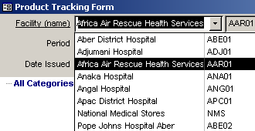
Figure 7-8 – Facility (Code) changed to Facility (Name)As shown in sample Figure 7-8, the Facility (Code) tag becomes Facility (Name) and a pull-down menu lists facilities listed by name.

- Select the facility you want from the pull-down menu, and click the left mouse button.

If the selected facility has a product tracking record for the current reporting period, it is displayed and appears similar to Figure 7-1 on page 1.

- If the selected facility does not have a product tracking record for the current reporting period, click the back arrow until a record is displayed.

- Repeat steps 1-2 to view product tracking records for additional facilities.

- Click Close when you finish viewing product tracking records.

Editing Product Tracking Records
- Select the facility whose product tracking data you wish to edit.

- Select a reporting period.

- Click the field you wish to change, type your changes and press <Enter>.

- Repeat steps 1-3 to edit product tracking records for additional facilities.

- Click Close when you finish editing product tracking records.

Validation Checks
When you modify a field on the Product Tracking form, Supply Chain Manager performs a validation check and displays a message informing you of any validation errors. For most validation checks, Supply Chain Manager makes the appropriate adjustment when you select Yes or OK. The most common validation error messages are the following—

Opening Balance
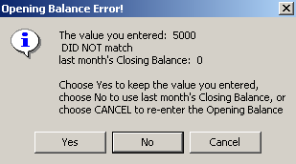
Figure 7-9 – Opening balance error messageIf the opening balance you enter differs from the closing balance for the previous reporting period, an error message (Figure 7-9) appears.

- Click Yes to keep the number you recorded.

- Click No to use last month’s closing balance.

- Click Cancel to reenter the opening balance.

 | The opening balance should always equal the closing balance reported during the previous reporting period.

Dispense by Purpose of Use
If the sum of quantities dispensed by the purpose of use you entered does not match the total dispensed entered, an error message similar to Figure 7-10 is displayed.
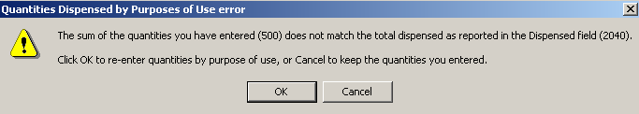
Figure 7-10 – Quantities dispensed by purpose of use error message

Closing Balance
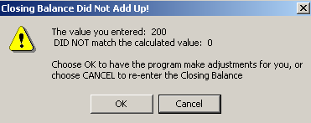
Figure 7-11 – Closing balance error messageIf the Closing Balance you recorded does not match the calculated number, an error message (Figure 7-11) appears.

- Click OK to keep the number you recorded and let Supply Chain Manager generate an adjustment.

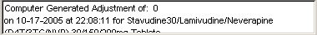
Figure 7-12 – Computer-generated adjustment commentSupply Chain Manager adds a note to the Comment field regarding the date and time the adjustment was made (Figure 7-12).

- Click Cancel to reenter the Closing Balance.
 | The closing balance recorded in Supply Chain Manager must equal the facility’s reported closing balance. Do not change the reported closing balance.

Average Monthly Consumption
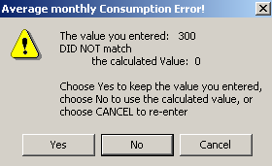
Figure 7-13 – Average Monthly Consumption Error message
The average monthly consumption for each product is calculated by dividing the total quantity dispensed to users by the number of periods to use for average calculation (see Section 4 – System Configuration for more information). If the number you recorded does not match the calculated number, an error message appears (Figure 7-13).

- Click Yes to keep the number you recorded.

- Click No to use the calculated number.

- Click Cancel to reenter the average monthly consumption.
 | When a facility is overstocked (above maximum), a negative number appears in the Quantity Required field.

Quantity Required
The quantity required is calculated by multiplying average monthly consumption by the maximum months of supply and subtracting the closing balance from the result. If the number you recorded does not match the calculated number, an error message (Figure 7-14) appears.
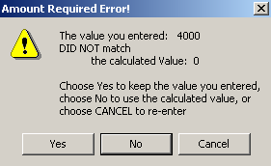
Figure 7-14 – Quantity Required Error message

- Click Yes to keep the number you recorded.

- Click No to use the calculated value.

- Click Cancel to reenter the quantity required.

Quantity Issued
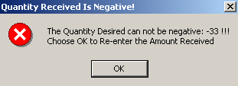
Figure 7-15 – Quantity Issued Error messageThe quantity issued is the amount the facility has received. This amount cannot be a negative number. If you enter a negative number, an error message (Figure 7-15) appears.

- Click OK and enter a positive number or zero (0).

Printing the Selected Product Tracking Record
- Click Print.

- Click Close when you finish printing the product tracking record.

Exporting Product Tracking Records
You can export product tracking records to a text or XML file for import into other logistics management software such as PipeLine.

- In the main menu, click the Utilities option.

- In the Utilities menu, click the Export Consumption Data option.

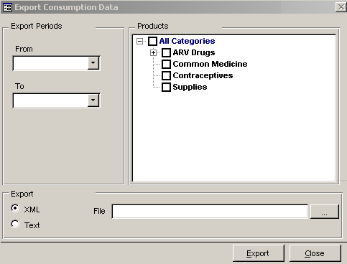
Figure 7-16 – Export Consumption Data formThe Export Consumption Data form (Figure 7-16) is displayed.

- In the Export Periods area, click the arrow to the right of the From pull-down box, click a starting period and click the left mouse button.

- Click the arrow to the right of the To pull-down box, click an ending period and click the left mouse button.

- In the Products window, click on one more boxes to the left of the categories and products in order to include them in the export file.

- In the Export area, click XML or Text file format.

- Click the ellipsis to the right of the File field.

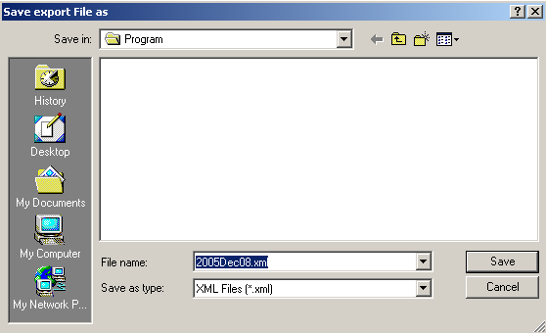
Figure 7-17 – Save Export File As formThe Save Export File As form (Figure 7-17) appears.

- Enter a file name in the File Name text box.

- To change the location of the export file, click the Save As pull-down box and select another directory.

- Click Save.

The Export Consumption Data form will again be visible.

- Click Export.

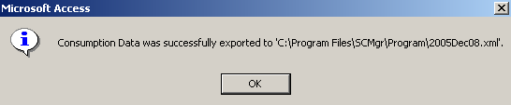
Figure 7-18 – Export complete messageIf the data are successfully exported, a confirmation message similar to Figure 6-15 will appear.

If you did not specify a directory in the Save Export File As form, the file will be saved to the default Supply Chain Manager directory.

The export file will contain the following data about each product within the export period specified—
- Product code
- Aggregated consumption at service delivery points (quantities dispensed to users)
- Aggregated adjustments at all distribution levels.

